I Give Thanks
G G/B C D
You have shown me favor unending
G G/B C D
You have given your life for me
G G/B C D
And my heart knows of your goodness
Em C D
Your blood has covered me
G D C D
I(We) will arise and give thanks to You, Lord my(our) God
G D C D
And Your Name I(we) will bless with my(our) whole heart(s)
G D
You have shown mercy,
C D Em7
You have shown mercy to me(us).
Am7-Em-D G
I (We) give thanks to You Lord.
G G/B C D
You have poured out your healing upon us
G G/B C D
You have set the captives free
G G/B C D
And we know it's not what we've done
Em C D
But by Your hand alone
Am7 G/B C D
You, O Lord, are the healer of my soul
Am7 G/B Bm7 C
You, O Lord, are the gracious redeemer.
Bm7 Am7 D
You come to restore us again
Bm7 Am7 D G
Used by Permission. CCLI #11103902 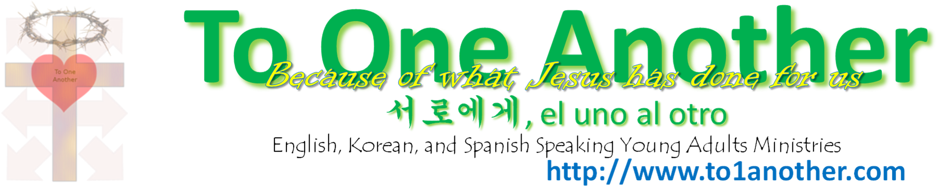
Yes, You come to restore us again, and again.

